Q1. Data types (30pt)

1. Vehicle license plate number?
UTF-8, Vehicle license plate number in the US are usually in the format of XX-0000, a combination of letters and numbers. So, 32-bit data types are not viable. It is also not a date time.

2. 12-digit bar code number for products?
32-bit signed integer or UTF-8 works because 12-digit bar code numbers are integers between -2,147,483,648 and 2,147,483,647, with no decimal points. At the same time, UTF-8 is also acceptable since the integers here are used as IDs, with the values themselves serving no purpose. It can also catch on to the problems of starting zeroes (i.e 00123 and 0123 are the same integers but might represent different products). However, UTF-8 is less efficient.

3. Financial transaction amount (positive, up to 1 million dollars)?
32-bit floating point. A 32-bit signed integer can represent whole numbers up to 1 million but lacks decimal precision. On the other hand, a 32-bit floating point number supports decimals, which is advantageous for financial calculations that require precision. It is simply impossible to do any financial transaction without the precision of floating points.

4. Class schedules in a university course directory? (e.g data. MWF 9-9:50am)
UTF-8, with both string and numbers present, the data format here doesn’t fit into the standards of datetime or 32-bit numbers.

5. The daily change in the number of Twitter followers for a user of Twitter?
32-bit signed integer, the daily change in user for every user cannot have decimal points. So just integers are enough here.

6. The probability of a homeowner defaulting on its mortgage?
32-bit floating point, it is highly probably for probability to have multiple decimal points, using integers only will heavily misrepresent the data. Probability also doesn’t contain strings.

Q2. Schema design (50pt)
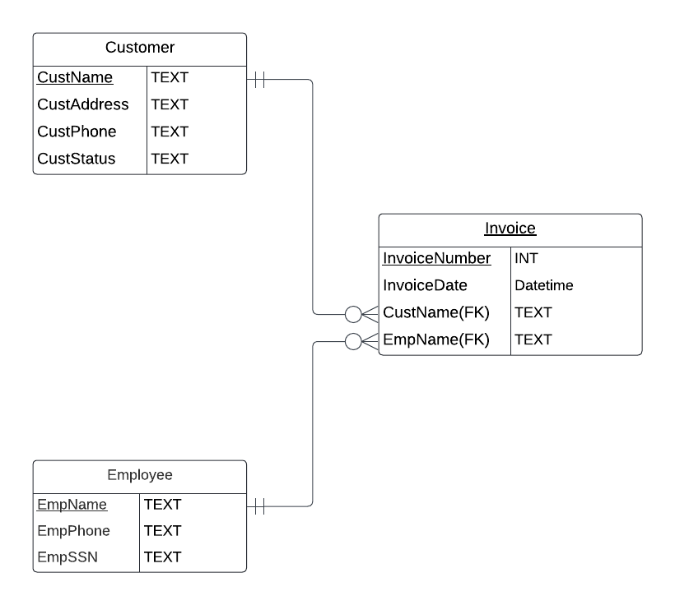

2) Assumptions:
- Each customer's name is unique to themselves. It could be useful to collect Customer ID instead of the name to handle customers with the same name. For employees since we have their SSN so that is not an issue.
- The relationship between invoices and customers, as well as invoices and employees, is direct and easily accessible, without the possibilities of considering many-to-many relationships (assuming one-to-many relationships).
- Customer status is a simple attribute of the Customer entity, so we can represent it using TEXT. If there are more complex customer status in the data, it could be a good idea to represent them in Integers and add a new column.

3) Relationships

Entities: Invoice, Employee, Customer
Each invoice is connected to exactly one customer, but a customer can have multiple invoices. This is a one-to-many relationship from Customer to Invoice.
Similarly, each invoice is connected to exactly one employee, but an employee can be associated with multiple invoices. This is a one-to-many relationship from Employee to Invoice.

Q3. Create tables. (20pt)

CREATE TABLE Customer (
CustName TEXT NOT NULL UNIQUE PRIMARY KEY,
CustAddress TEXT,
CustPhone TEXT,
CustStatus TEXT
);

CREATE TABLE Employee (
EmpName TEXT NOT NULL UNIQUE PRIMARY KEY,
EmpPhone TEXT NOT NULL,
EmpSSN TEXT NOT NULL UNIQUE
);

CREATE TABLE Invoice (
InvoiceNumber INTEGER NOT NULL PRIMARY KEY,
InvoiceDate TEXT,
CustName TEXT NOT NULL,
EmpName TEXT NOT NULL,
FOREIGN KEY (CustName) REFERENCES Customer(CustName),
FOREIGN KEY (EmpName) REFERENCES Employee(EmpName)
);

----- Insert Tables

INSERT INTO Customer (CustName, CustAddress, CustPhone, CustStatus) VALUES
('Frank Desoto', '2121 NE, Bellevue, WA98004', '422-4982', 'Valued'),
('Gregory Mattson', '752 Tax Ln, Redmond, CA 98225', '363-9361', 'Valued'),
('Carmen Aguilar', '101 Ave, Kent, WA 98126', '322-1178', ' ' ),
('David Cunning', '115 Pine St, Seattle, WA 98134', '98062', 'Preferred');

INSERT INTO Employee (EmpName, EmpPhone, EmpSSN) VALUES
('Estela Rosales', '363-9948', '111-22-3333'),
('Kath Erlic', '322-6992', '555-66-7777'),
('Kira Bently', '527-4992', '999-88-7777'),
('Shanon Black', '322-6992', '335-45-6677');

INSERT INTO Invoice (InvoiceNumber, InvoiceDate, CustName, EmpName) VALUES
(1300, '06/15/23', 'Frank Desoto', 'Estela Rosales'),
(1301, '06/15/23', 'Gregory Mattson', 'Kath Erlic'),
(1302, '06/15/23', 'Carmen Aguilar', 'Kira Bently'),
(1303, '06/16/23', 'David Cunning', 'Kira Bently'),
(1304, '06/16/23', 'Carmen Aguilar', 'Shanon Black'),
(1305, '06/17/23', 'Frank Desoto', 'Estela Rosales');

2) Assumptions:
- Again, each customer's name is unique to themselves. It could be useful to collect Customer ID instead of the name to handle customers with the same name. For employees since we have their SSN so that is not an issue.
- Datatypes are assumed based on the context and common sense. The thought process is explained in the previous Schema assumptions.
- Foreign keys used are CustName and EmpName, reasonable choices although ID could be better, we don’t have that in this dataset.
- Not Null conditions used on columns that we don’t want to be null, like customer name and employee name.
- Primary keys assumed to be EmpName, CustName, InvoiceNumber respectively.
- For Customer status, CustPhone, CustAddress assumed null value is acceptable considering they are usually additional information that can be missing with very little impact to the overall data structure.

